得分

第七题（12 分）
下面是一个基于进程的并发echo server 的主要代码（省略了与本题无关的部分），每段代码都注释了相应的功能，请补充空缺的代码（可能是 0 行或多行）。请确保任何由你打开的文件描述符都被显式地关闭。
int open_listenfd(char *port) {
struct addrinfo hints, *listp, *p; int listenfd, optval = 1;

/* Get a list of potential server addresses */ memset(&hints, 0, sizeof(struct addrinfo)); hints.ai_socktype = SOCK_STREAM; hints.ai_flags = AI_PASSIVE | AI_ADDRCONFIG; hints.ai_flags |= AI_NUMERICSERV; Getaddrinfo(NULL, port, &hints, &listp);

/* Walk the list for one that we can bind to */ for (p = listp; p; p = p->ai_next) {
/* Create a socket descriptor. If failed, try the next */ if ((listenfd = socket(p->ai_family,
p->ai_socktype, p->ai_protocol)) < 0)
(1)
/* Eliminates error from bind */ Setsockopt(listenfd, SOL_SOCKET, SO_REUSEADDR,
(const void *)&optval, sizeof(int));
/* Bind the descriptor to the address */
if (bind(listenfd, p->ai_addr, p->ai_addrlen) == 0) else /* Success, use the current one */
/* Bind failed, try the next */
}
(4)
if (!p) return -1; /* No address worked */

/* Make it a listening socket*/
if (listen(listenfd, LISTENQ) < 0) {
(5)
return -1;
}
return listenfd;
}
(2)
(3)

void echo(int fd); /* service a client via fd */ void handler(int sig) {
while (waitpid(-1, 0, WNOHANG) > 0); return;
}
int main(int argc, char **argv) { int listenfd, connfd; socklen_t clientlen;
struct sockaddr_storage clientaddr;

Signal( (10) , handler); listenfd = Open_listenfd(argv[1]); while (1) {
clientlen = sizeof(struct sockaddr_storage)
(6) = Accept( (7) , (SA *)&clientaddr, &clientlen); if (Fork() == 0) {
/* Child services client and close fd */
(8)
exit(0); /* Child exits */
}
(9)
}
}
（第(9)空 3 分，其余每空 1 分; 共 12 分）

答案：
- continue;
- break;
- Close(listenfd);
- Freeaddrinfo(listp);
- Close(listenfd);
- connfd
- listenfd
- Close(listenfd); echo(connfd); Close(connfd);
- Close(connfd);
- SIGCHLD

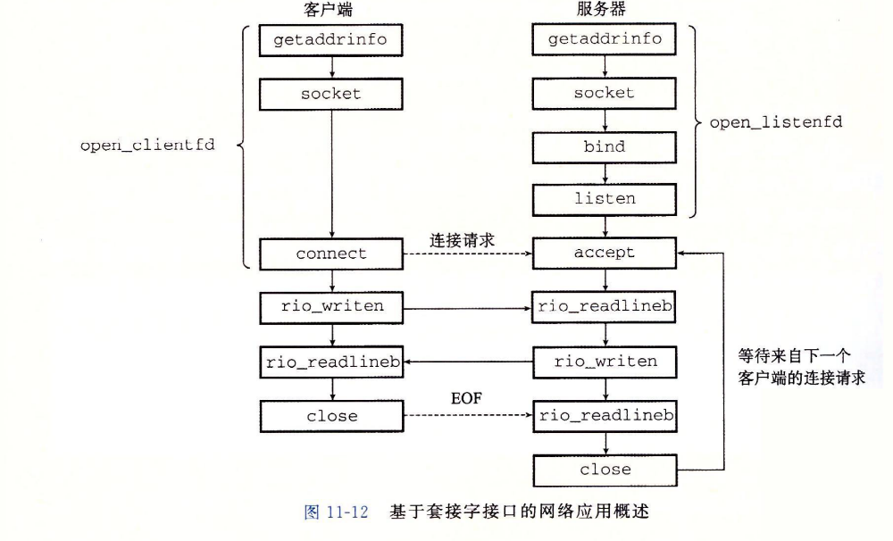
关于getaddrinfo 和 freeaddrinfo：
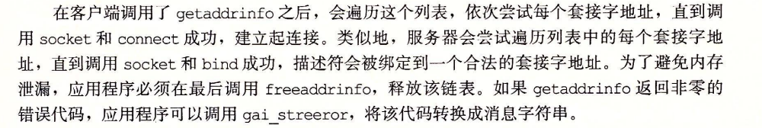

关于Accept函数：
